SSN COLLEGE OF ENGINEERING

DEPARTMENT OF COMPUTER SCIENCE AND ENGINEERING

UCS1712 – GRAPHICS AND MULTIMEDIA LAB

EX NO: 7 – Cohen Sutherland Line Clipping Algorithm

Name: S.Nachammai Devi Pooja Class & Sec: CSE B

Roll No: 185001096 Date: 5/10/21

**AIM:**

To write a C++ program using OPENGL to clip a line using Cohen – Sutherland line clipping algorithm.

**ALGORITHM:**

1.Create a cpp file

2. Import the libraries required for OPEN GL

3. Initialise the display by setting the dimensions 600×600.

4.Clear the display by making the colour white

5.Read the co-oridantes of vertices (xi, yi) for all the vertices.

6.Read window coordinates xwmin , ywmin , xwmax, ywmax

7.Read line coordinates xd1 , yd1 , xd2, yd2

8.If ((c & 8)>0) perform horizontal top intersection.

9.If ((c & 4)>0) perform horizontal bottom intersection.

10.If ((c & 2)>0) perform horizontal right intersection.

11.f ((c & 1)>0) perform horizontal left intersection.

10.While executing on pressing x perform clipping.

11.Display clipped line.

**CODE:**

**#include <iostream>**

**#include<GLUT/GLUT.h>**

**#include<math.h>**

**using namespace std;**

**void display();**

**float xmin=-150;**

**float ymin=-200;**

**float xmax=150;**

**float ymax=200;**

**float xd1,yd1,xd2,yd2;**

**void init(void)**

**{**

**glClearColor(0,0,0,0);**

**glMatrixMode(GL_PROJECTION);**

**gluOrtho2D(-300,300,-300,300);**

**}**

**int code(float x,float y)**

**{**

**int c=0;**

**if(y>ymax)c=8;**

**if(y<ymin)c=4;**

**if(x>xmax)c=c|2;**

**if(x<xmin)c=c|1;**

**return c;**

**}**

**void cohen_line(float x1,float y1,float x2,float y2)**

**{**

**int c1=code(x1,y1);**

**int c2=code(x2,y2);**

**float m =(y2-y1)/(x2-x1);**

**while((c1|c2)>0)**

**{**

**if((c1 & c2)>0)**

**{**

**exit(0);**

**}**

**float xi=x1;float yi=y1;**

**int c=c1;**

**if(c==0)**

**{**

**c=c2;**

**xi=x2;**

**yi=y2;**

**}**

**float x,y;**

**if((c & 8)>0)**

**{**

**y=ymax;//horizontal top intersection**

**x=xi+1.0/m*(ymax-yi);**

**}**

**else**

**if((c & 4)>0)**

**{**

**y=ymin;//horizontal bottom intersection**

**x=xi+1.0/m*(ymin-yi);**

**}**

**else**

**if((c & 2)>0)**

**{**

**x=xmax;//vertical right intersection**

**y=yi+m*(xmax-xi);**

**}**

**else**

**if((c & 1)>0)**

**{**

**x=xmin;//vertical left intersection**

**y=yi+m*(xmin-xi);**

**}**

**if(c==c1)**

**{**

**xd1=x;**

**yd1=y;**

**c1=code(xd1,yd1);**

**}**

**if(c==c2)**

**{**

**xd2=x;**

**yd2=y;**

**c2=code(xd2,yd2);**

**}**

**}**

**display();**

**}**

**void mykey(unsigned char key,int x,int y)**

**{**

**if(key== 'x')**

**{**

**cout<<"COHEN - CLIPPING";**

**cohen_line(xd1,yd1,xd2,yd2);**

**glFlush();**

**}**

**}**

**void display()**

**{**

**glClear(GL_COLOR_BUFFER_BIT);**

**glColor3f(0.0,1.0,1.0);**

**glBegin(GL_LINE_LOOP);**

**glVertex2i(xmin,ymin);**

**glVertex2i(xmin,ymax);**

**glVertex2i(xmax,ymax);**

**glVertex2i(xmax,ymin);**

**glEnd();**

**glColor3f(1.0,0.0,1.0);**

**glBegin(GL_LINES);**

**glVertex2i(xd1,yd1);**

**glVertex2i(xd2,yd2);**

**glEnd();**

**glFlush();**

**}**

**int main(int argc, char** argv) {**

**cout<<"Cohen Sutherland Clipping\n";**

**cout<<"Enter window Co-ordinates:";**

**cin>>xmin>>xmax>>ymin>>ymax;**

**cout<<"Enter line Co-ordinates:";**

**cin>>xd1>>yd1>>xd2>>yd2;**

**glutInit(&argc,argv);**

**glutInitDisplayMode(GLUT_SINGLE|GLUT_RGB);**

**glutInitWindowSize(600,600);**

**glutInitWindowPosition(0,0);**

**glutCreateWindow("Cohen Sutherland Clipping");**

**glutDisplayFunc(display);**

**glutKeyboardFunc(mykey);**

**init();**

**glutMainLoop();**

**return 0;**

**}**

**OUTPUT:**

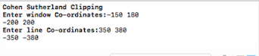

**Initial:**

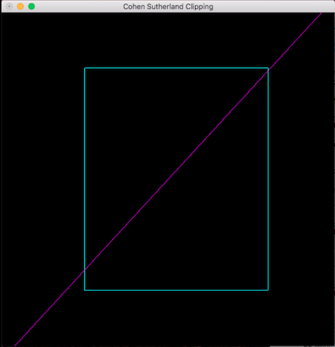

**After Clipping:**

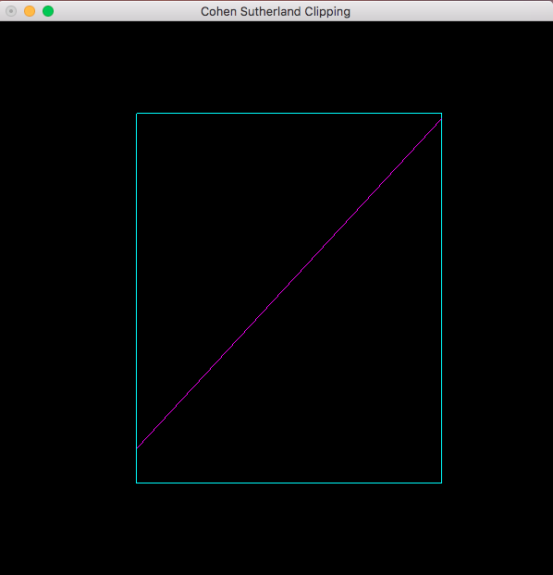

**RESULT:**

A C++ program using OPENGL to clip a line using Cohen – Sutherland line clipping algorithm has been implemented successfully.